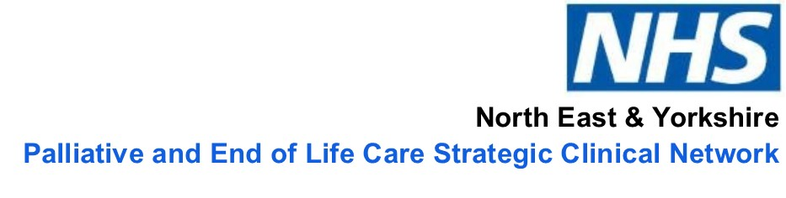
Humber and North Yorkshire Palliative & End of Life Care Network

Do you care about improving outcomes and reducing health inequalities in our region?

An exciting opportunity has arisen to become a Humber and North Yorkshire Palliative & End of Life Care (PEoLC) Lay Representative bringing the perspective of the patients, the wider community and health inequalities to the network group and meetings

The Opportunity:
The Humber and North Yorkshire PEoLC Network is a collaborative through which service providers and commissioners work together to deliver the related ambitions of the NHS Long Term Plan and The Ambitions Framework for Palliative & end of Life Care. We currently have a vacancy for a Lay Representative to work with the Network to deliver its work plan objectives.

The Role Involves:
As a Lay Representative you will be asked to attend pre-arranged meetings, forums and events related to Networks work plan; this will be for a maximum of 1/2 day (4 hours) per month (plus occasional ad hoc meetings. Maximum 8 full days per year plus travel expenses). The responsibilities of a Lay Representative include:

- Championing a diversity of views to include patients and the wider community.
- Provide some challenge as a critical friend into Network meetings.
- Champion and advocate for increasing patient and public awareness of the Networks priorities, outcomes and achievements.
- Review workstream/project plans and other associated documentation as requested to enhance the Networks focus on public involvement.
- Comply with the Standards of Conduct, respecting the confidential nature of documents and discussions where appropriate.

Your expenses:
NHS England greatly values in depth partnership working with members of the public in leadership roles. This involves a significant contribution from public, patients or carers. The Lay Representative role will receive a nominal involvement payment as well as out of pocket expenses.

As a Lay Representative you will need to have:
- Knowledge or experience of NHS, social care and/or public health services.
- An interest in PEoLC services.
- Experience of speaking in large groups.
- Ability to listen and to express views.
- Ability to work as part of a group with people from a wide range of different backgrounds.
- Understanding of health inequalities and their interaction with patient/carer experience
- Ability to understand and evaluate a range of information and evidence.
- Previous experience of involvement in health care forums and meetings.
- An awareness of, and commitment to diversity and equality of opportunity.
- A commitment to seeking the views of a range of stakeholders and an ability to bring perspectives beyond personal experience.
- Understanding of the need for confidentiality.
- Ability to be flexible and adaptable to changing situations.

The Network is committed to being as inclusive as possible in all that we do and we will therefore adopt any reasonable adjustments required to enable you to fulfil this role

To Apply:
In the first instance please contact Lynn Andrews on 07545662017 or email lynn.andrews2@nhs.net
Closing date for applications for this role is: 5th September 2022

Interview date: Week commencing 19th September- Date and location to be confirmed

Please note, this advert may close earlier if sufficient applications are received before the closing date.

